**Lesson #11: Standard integers (stdint.h) and mixing integer types**

* We talk about fixed with integer types stdint.h, mixing data types
* This lecture is important for job interview
* Why I am taking this lecture?
* C standard does not prescribe the size of **int** and **unsigned,** both of them are machine dependent, int is 32 bit wide on 32 bit machine, 16 bit wide on 16 bit machine 8 bit wide on 8 bit machine
* We also have the following datatypes

**char x;**

**unsigned char x;**

**short x;**

**unsigned short;**

**long x;**

**unsigned long x;**

**int x;**

**unsigned x;**

* C standard describe, size of:
  + short < int < long
  + char -> typically 1 byte can be signed or unsigned but depending on compiler options
* In embedded work, it is important to know the size, signededness and dynamic range of your variables so your code runs in same way regardless of the target processor
* The general approach is taken, define a new datatype of each fixed width integer
* Example MicroC / OS-11 RTOS uses typedef statements to define the fixed with integer type, where each typedef defines a new type and should be read backwards
* Basically you create char of your own choice of size
* Normally we put this code into a header file
* We should not blindly create this, because even when you define it, this process is still dependent of the processor
* To tackle this problem, in C99 ISO, C authors have defined some standard names and made compiler vendor responsible for providing the appropriate typedefs in a standard library header file, this C99 ISO consist on a file named **stdint.h**
* You need to check whether your compiler supports the C99 standard or not, IAR does
* You can look inside the stdint.h file because it is inside your IAR toolset 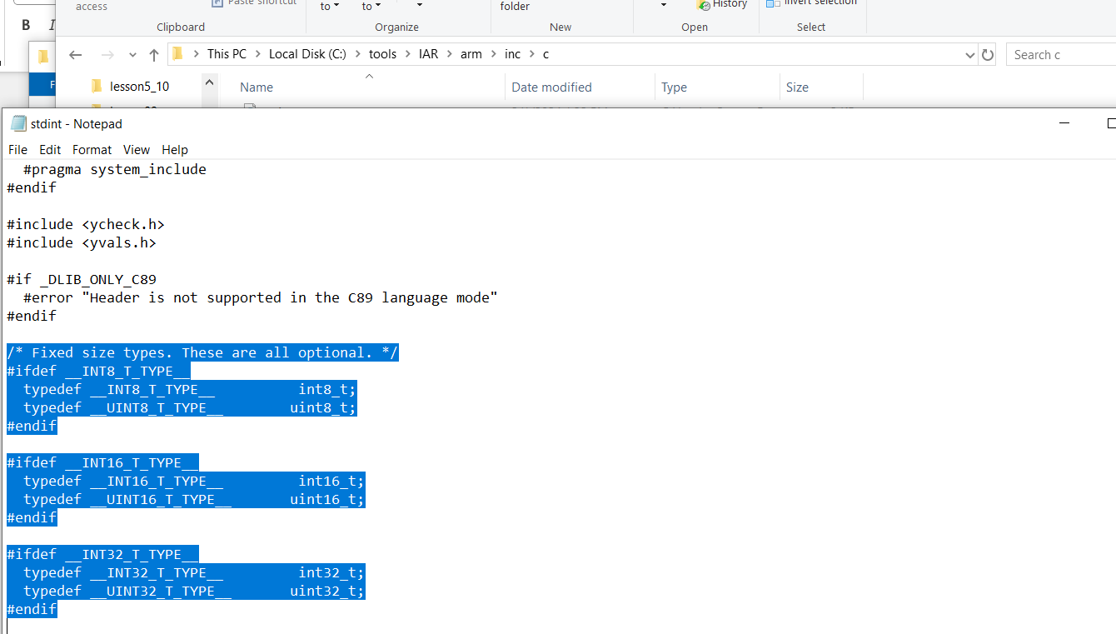
* The most highlighted ones above are the most important datatyeps
* It is counter productive now to create new names for your use, u must use this header file
* Microsoft visual C++ compiler is not C99 **complaint,** so If you wish to use for developing embedded code in PC you can only do it if you provide your own stdint.h header file
* We create using the keywords (int8_t) to create a fixed with datatypes
* We use sizeof(variable) to verify this
* Here you should also notice that the order higher order bits of datatypes are assigned up to the RAM, signed datatype is above unsigned datatype in RAM
* This also proves one more thing that the Global variable lives in the RAM, because all their addresses are starting from 0x20000000 HEX which is the starting address of RAM in ARM boards

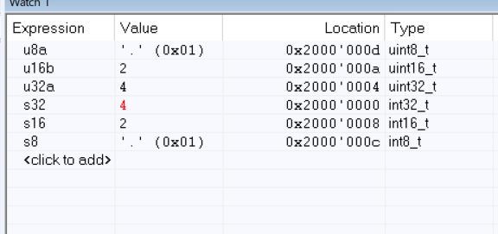

* Observe how data being transferred between these defined datatypes of defined width
* Address of u8b is 0x20000014 == 0x200000E, which is being loaded into **R1** register by the LDRB, STRB instruction store the **R1** into the 1-byte variable u8b
* Similarly instruction LDRH is used to load the **u16a** into **R1** and STRH use to store **R1** in **u16b**
* ARM Processor has special instructions LDRB and STRB to read and write bytes, LDRH and STRH to read and write huff words, plain STR and LDR to read and write whole words into memory
* When we compare the memory view and the register view we found out that, the order is reversed, memory view shoes that, all 4 bytes are placed reversed in order, why? Because ARM is Little Endian Machine, ARM core has configurable endianness, but virtually all silicon vendors such Texas Instruments choose the little endian configuration, little endian means the lower order bytes from a register are placed at the lower addresses than higher order bytes.
* Example here Least Significant Byte e4 from R1 register has been stored by the last STR instruction at a lower address than other bytes of the **value**
* However large endian can order the bytes of a value in a high end processor or big endian machine which was PowerPC used in MAC computers before they switched to x86
* Type conversions in C are rather complicated, lets learn how we convert the datatype in C
* We added two **fixed size 16 bit** variables and save the result into **fixed size 32 bit** variable
* C automatically always promotes any **smaller integers** to the **built-in type int** or **unsigned int** before performing any calculations, on 32 bit ARM machine the promotion is 32 bit which is the size of the **int** on ARM machine, meanwhile in MSP430 which is a 8 bit machine, so on MSP430 there was no real promotion, because the type **int**, is only 16 bit wide in MSP430, so MSP430 even though converting the datatype still forced the computation in 16 bits, because that is the size of the int on this machine, as aresult of using 16 bit int on a 32 bit code is the **overflow and value is truncated,** that is the reason why we saw 4464 instead of 70000 like in TIVA C.
* The tricky aspect of this example is result of the computation is assigned to a 32 bit wide number which has enough dynamic range to represent 70000 – this is where every developer got off
* Remember that : the precision in which the computation is performed **does not depend on the left hand side of the assignment.**
* **How would you fix this problem?** You need to enforce promotion to **32 bit precision** of the at least one of the operands, this way the other implicit conversion rule of the C language will apply, which is the, “computation is performed at the largest precision of the involved operands”, specially if one of the operand is 32 bit wide, the other will be promoted to 32 bits and finally the whole computation will eventually be performed at 32 bits.
* **The solution is** to explicitly cast**(convert)** one or both of the operands into (uint32_t)
* The more extended machine code is generated to do that on MSP430 machine
* Through this way get the final result of 70000
* Remember: However this would not cause any extra cycle on 32 bit machine but does in 8 vit or 16 bit machines
* The next problem we face the change of sign in arithematic operation
* When we try to subtract 1-u16a where u16a is an unsigned in 16 bit number and since the result is negative we saved this into the signed 32 bit. We ran this code onto TIVA and MSP430
* TIVA generated exactly -90 meanwhile MSP430 generate big _ve number why?
* Implicit Conversion rule help us and say that, when you mix **signed** and **unsigned** operands both are promoted to **unsigned int** and the result is unsigned int, this unsigned int result converted to signed 32 bit as mentioned at the code on the LHS of the assignment which is made above the code
* When this expression is evaluated on 32 bit ARM, unsigned value is 32 bit wide so it fills completely the s32 variable which is signed 32 bit and the value is reinterprested in **2’s complement representation** as negative, when the same expression is einterpreted in MSP430, the unsigned int here only 16 bit wide, and fills up only the lower half of s32 variable, because the value is unsigned, it is not signed extended to 32 bits and is interpreted as a big +ve number
* **The solution to this problem is** to avoid mixing signed and unsigned , instead you should explicitly cast unsigned variable to a signed type, not also in this case, the problem was not **insufficient number of bits** so that is why you cast into int16_t, after making such changes when you run the code on MSP320, the desired result is obtained
* **The problem of mixing signed and unsigned arises when making comparisions**
* When you compile the where it is checking whether u32_t > 1, the compiler throws an error and says that you have **pointless integer comparison,** when you think about it, it make sense, because the smallest value an unsigned number can hold is 0, which is always bigger than -1, the warning says that the comparison always **false** which is exacty the opposite result of what you think, because this is what compiler thinks, you cannot put breakpoint on if branch but on else branch
* **In the mixed signed and unsigned expressions, that C standard promotes the signed operands to unsigned int, which means that** the negative 1 value is promoted to ‘unsigned int’ which is 0Xffffffff which is the largest value of the unsigned int can hold, that’s why comparison always false.
* **You fix this problem by** explicitly cast from unsigned to signed
* **The last problem we would discuss today is the** binary operation on small integers.
* When we ran the program where if checks whether ~u8a == 0, u8a has a value 0xff, the comparison looks true and also compiler doesn’t throw any error, because 1’s complement inverts all the bit which eventually make it 0, but in fact the compassion will always be False, although the compiler doesn’t report warning in this case.
* However you cannot even set a break point inside if, that’s why the compiler has eliminated the whole thing.
* The compiler knows the comparison can never be TRUE, because the **byte u8a** will be promoted to int, so the MSB will be 0, when 1s compliment is taken the MSB will be all 1s, so the result can never be 0
* **The solution of this problem is** to revert the promotion or stop this promotion to int by casting the (uint8_t) inverted value back to the byte
* **Arithmetic operation on range , Arithmetic operation of signed and unsigned, Comparison between signed and unsigned**

**Lesson# 12: Structures in C and Cortex Microcontroller Software Interface Standard (CMSIS)**

* Just like array data type, **structure** are another way of grouping together the variables but the difference is that, the structures can group together the variables of different types
* They permitted a group of **related variables** to be treated as a unit, you can interact with hardware in an elegent way
* Understand struct datatype as the collection of **x** and **y on a xy plane**
* One important aspect, after enclsing brackts of struct, if you put variables, you omit the struct, but normally we placed the semicolon and give struct a single name, after that you can assign new variables to struct
* But in C every time you assign new variables to a struct Data structure, you need to use **struct** keyword, to avoid this use **typedef** keyword before as the following way, suppose you define 2 varaibles inside struct, now outside its data structure you want to use 2 new variables to represent it

struct pointer { //01

uint16_t x; //02

uint8_t y; //03

};

struct pointer pa, pb; //04

//OR

typedef struct pointer pointer; //05

pointer p1, p2; //06

* You can even placed //05 above and over //01
* //04 tagname occupies different space //05 typedef
* To remove pointer repitation

typedef struct { //01

uint16_t x; //02

uint8_t y; //03

}pointer; //untagged struct decleration

pointer p1, p2; //04

* Mentioned above way of decelerating struct in this way is also the lastest safety C standard mentioned in MISRA 2012, its rule 2.4 mentions that you should not use untagged tag declaration
* The notable exception is self-referential structures, such as nodes of linked list or trees
* How you can access those variables inside the structure

p1.x

* Also like other arithematic instructions we don’t need to use () outside the struct members the other instruction
* First thing we notices was that the point of struct have 4 bytes of space and its members, since x has a **point** datatype.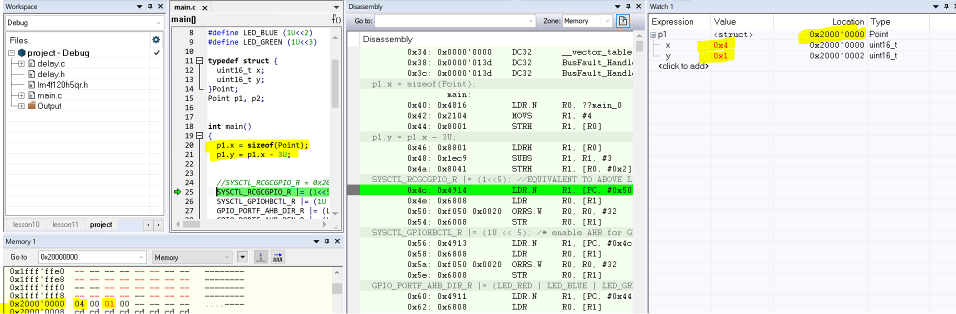
* Above in memeory view we can see that p1.y being padded by 0s, also in watch 1 widnow you observe the answer of why **y** assigned 0x20000002 instead of 0x20000001
* Each address also contains capacity to store 4 bytes
* Lets investigate this padding by reversing the members when defined in the memory, the affect of that, the order of members also reversed in memory, the members inside struct declearation when declared first get the top most address
* This means that the compiler honours the order in which you declare the members of struct in the memory as well, also this is the compiler that inserts extra padding itno your bytes
* The question arises that why compiler waste bytes by padding it? Instead of placing at half word member it an odd address
* To investogate we forced the compiler to not waste any bytes, this is not possible in standard C but most embedded compilers provides a way to tightly packed without any padding
* IAR Compiler provides this extension, by extending keyword __packed infront of struct keyword
* Protects y variable to be filled with 0
* The compiler handles it very efficiently to the chnages, yes
* The code **without __packed** keyword, you notice the padding as well as the address the 2nd declared variable obtained is 0x20000002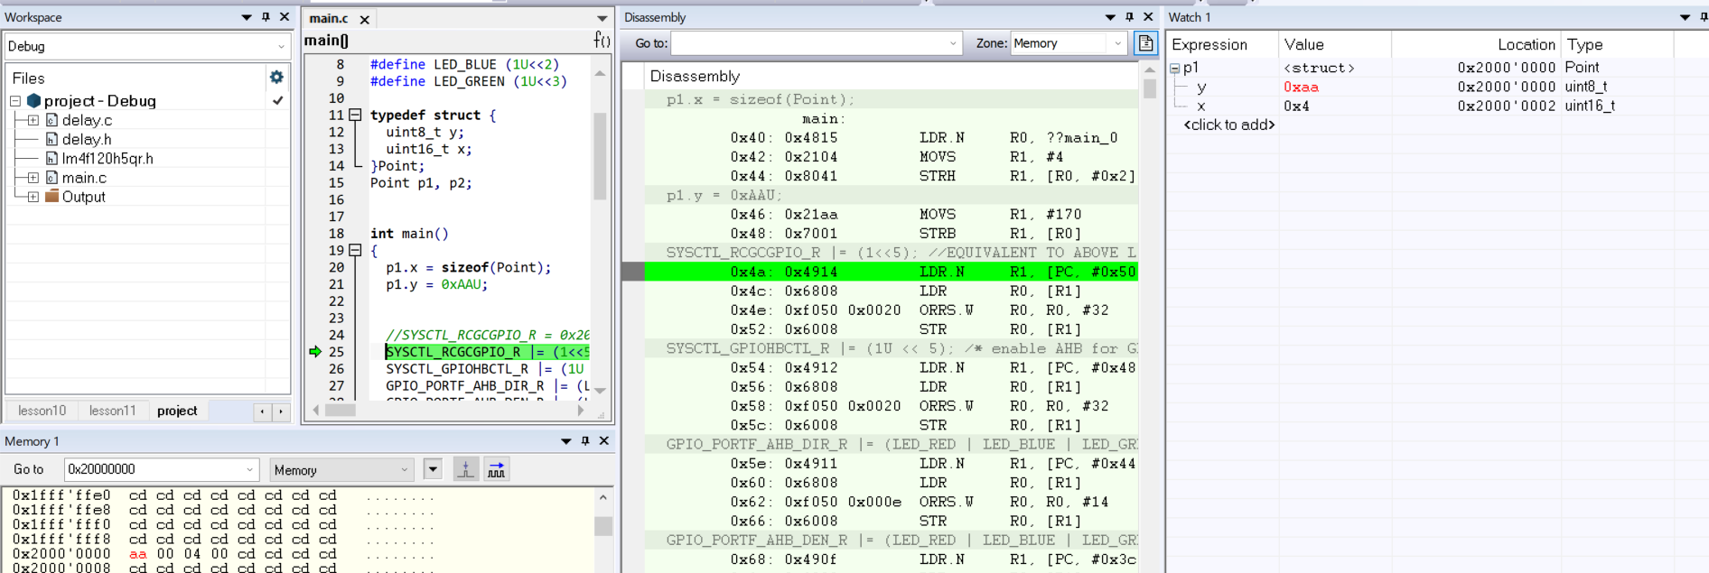
* The code **with __packed** keyword, you notice the **removal of** padding as well as the address the 2nd declared variable obtained is 0x20000001
* If __packed keyword handled by CPU just fine then what to worry about?
* Make some changes
  + Go to options->
    - general options->Target->core-> select CORTEX – M0
    - debugger
      * driver ->TI stellaris
      * download -> check Use Flash Loader(s), verify download
* Now after making such changes I will run this code in TIVA C board, even though the processor has **CORTEX m4 processor not cortex m0**
* All instructions between CORTEX M processors are backward compatible
* Before running the code on baord, I will save the insructions of p1.x and p1.y here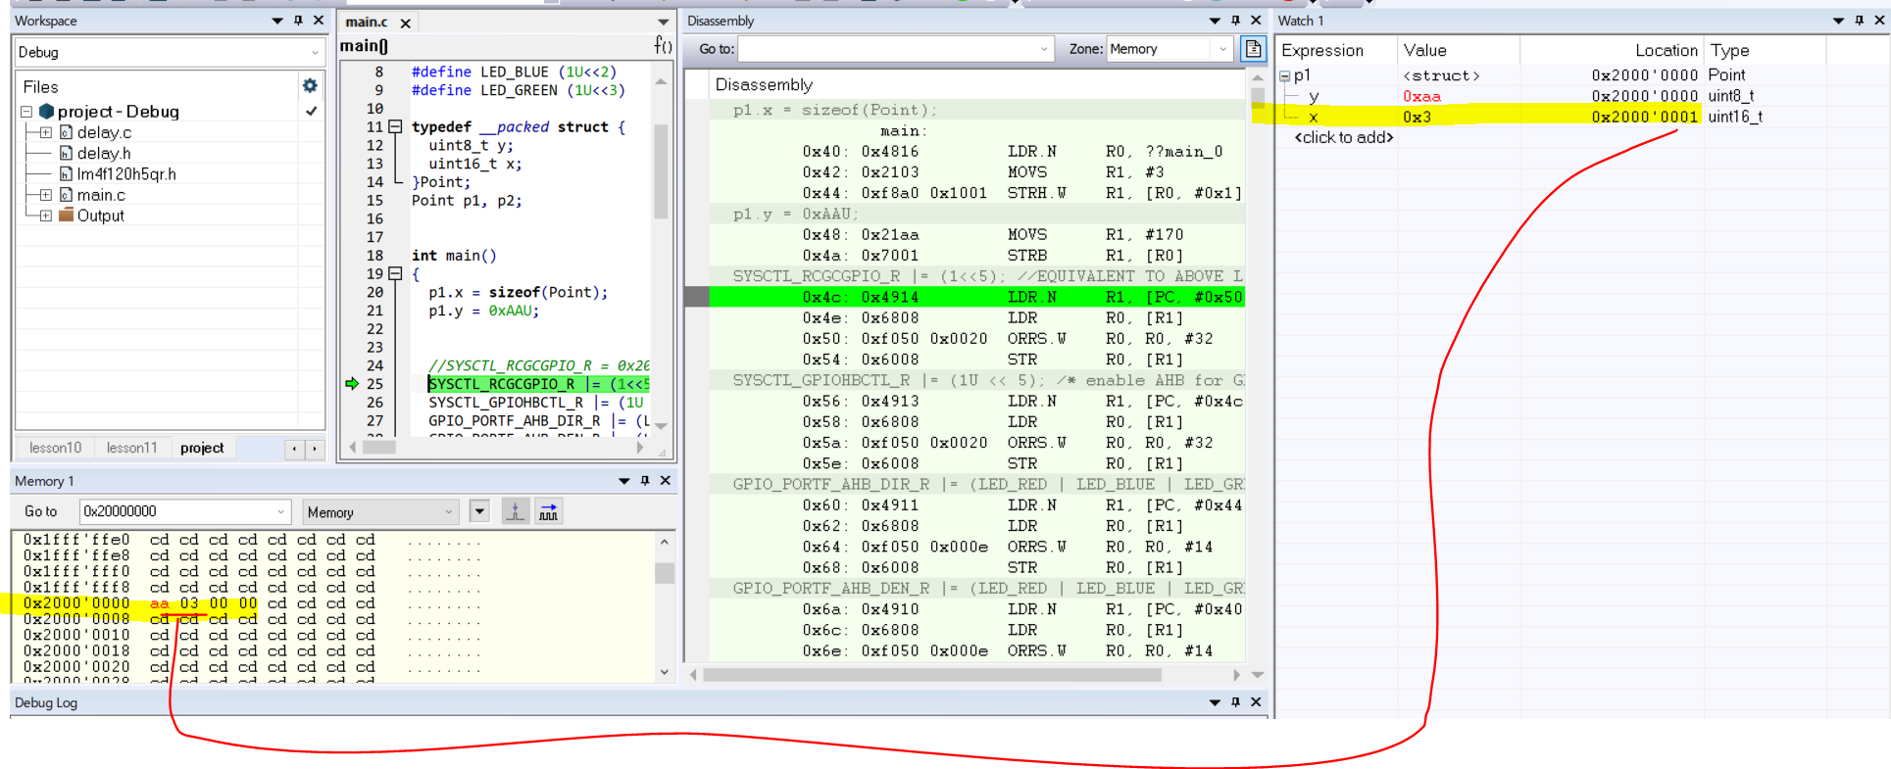
* You can see that p1.x (LDR.N, MOVS, STRH.W) and p1.y(MOVS, STRB)
* Now I applied this on the hardware

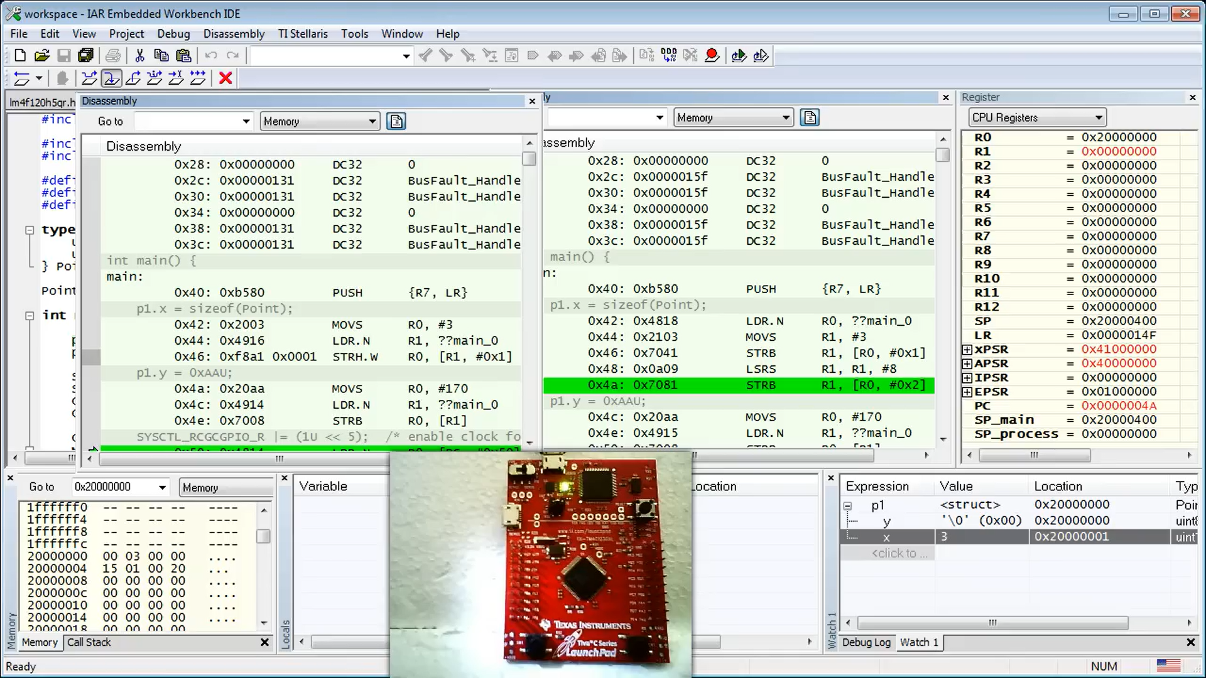

* Observe how p1.x instructions got increased
* So you can see that cortex m4 uses less instruction meanwhile on the same C compiled code coretxt m0 create a different code
* You can argue that Cortex M0 does have STRH instruction then it simply use it here? The answer is simple, STRH instruction of CORTEX M0 is not that much powerful, what I mean that it cannot access **half word allocated at an odd address**
* To prove this I put the SS of p1.y of cortex M0 and you can find no difference between the instruction of CORTEX M0 and CORTEX M4 among them

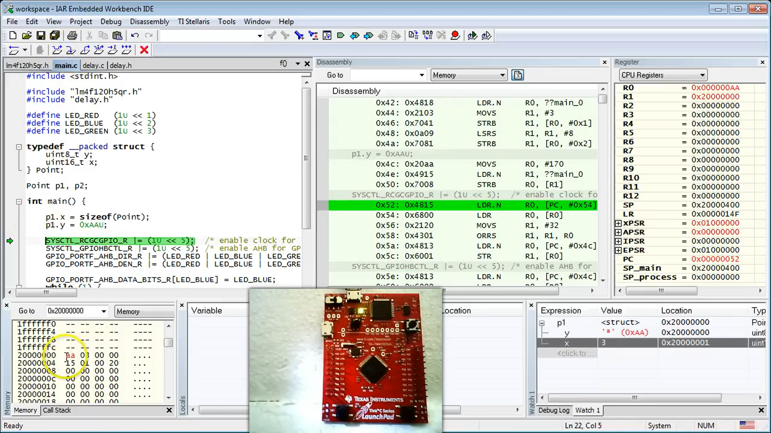

* The alignment of data into the memory does matters to the processor
* You need to use the padding on data sensibally only when you need to avoid the padding
* Strcutures can contain:
  + Other structures
  + Arrays
* The variables of structure type can also be called as instances, how its made? Suppose you created a struct Widow now you do this:

Window w;

* w becomes the instance of Window
* You can access the members of the given instances, IAR example
* You can also assign whole **structure** to another structure, and whole instance **instance of structure** to another instance of structure.
* Simple looking statements of copying structure copies the sizeable memory from one location to another which often not a good practice thus we use, thus we pointers to structures
* So we use pointers and copy only the address of a particular variable not its values thus, by referering we can use its vales as well
* Now how to access the members of the structure, the C language provides 2 ways;
  + (*pp) -> to obtain the object of a pointer , pointed to by the pointer
  + pp is the pointer to point, *pp is the point type, now you can access any member using the . operator
  + ->
* Look at this, pointer which is created for the struct, got the address of members of the struct, now can only access that specific struct members, here I would show you the wp, which stores the address of w2 which is the instance/hook of the Window struct, and pointer can only access the members of the Window struct not hook, hook give access to members to the pointer (*pp)

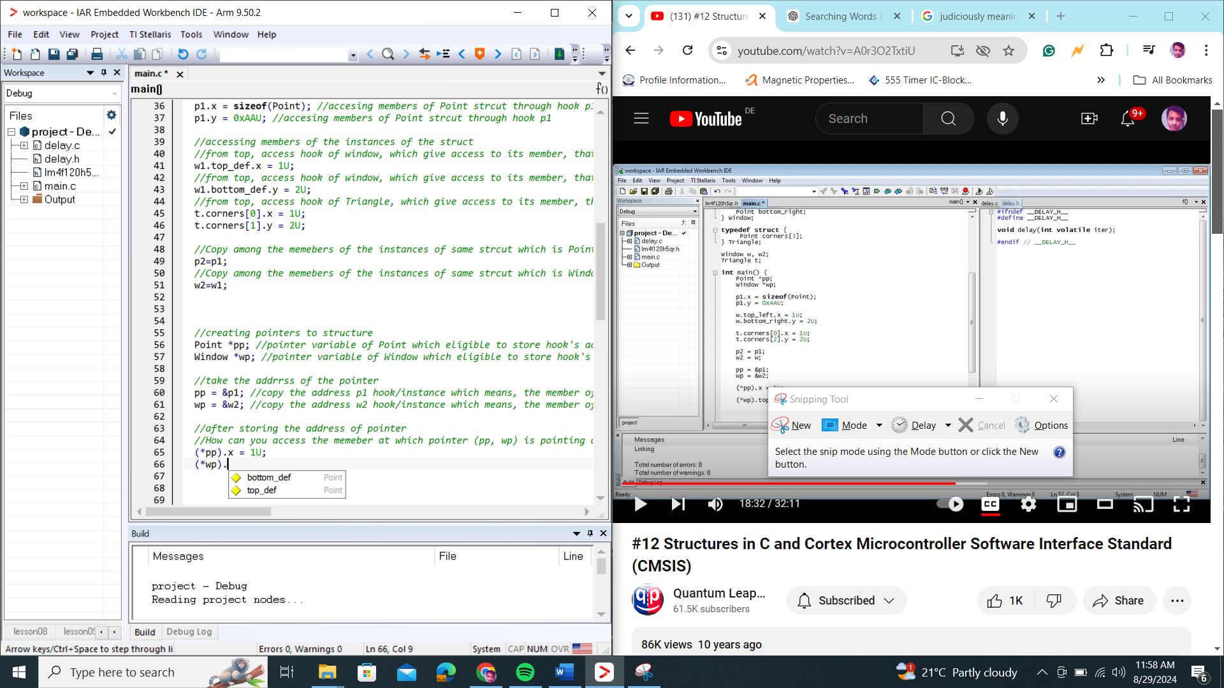

* Pointers access in two ways, both doing same operation
  + (*pp).x;
  + pp->x;
* Dubug the code: here STRH instruction appear in cortex m0, means if the values are correctly aligned with the padding, 2nd is the explanation of STRH, which makes the contents of R0 registers must be stored at the address of R1+offset 2 bytes 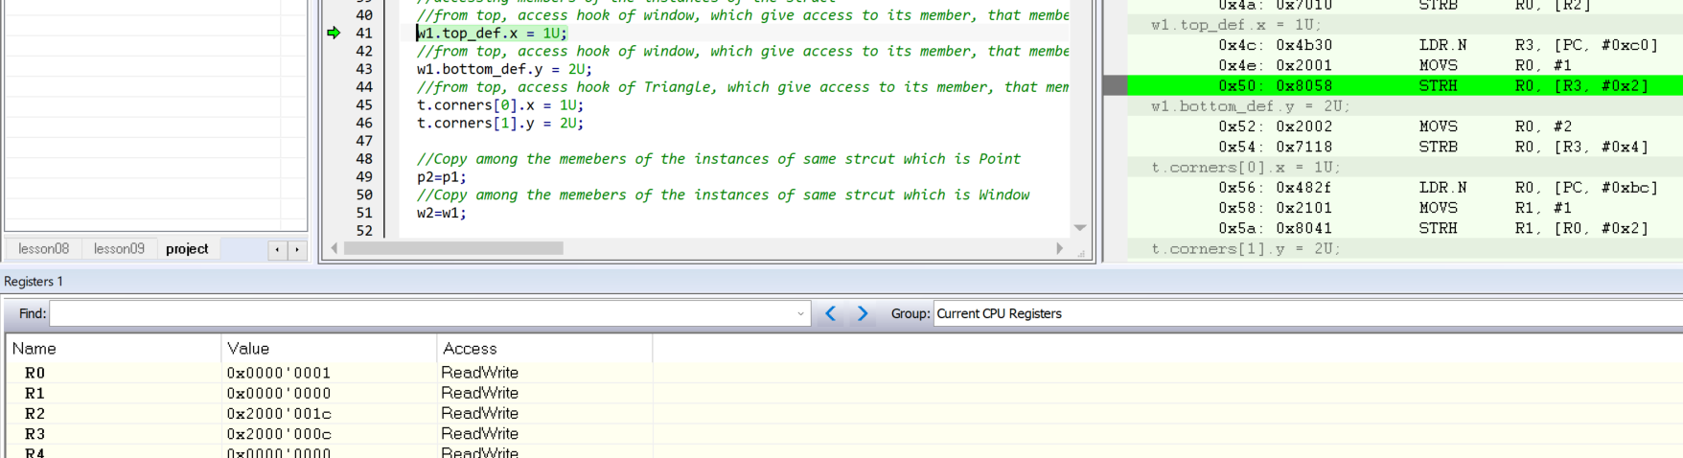
* Struct is like a register, with its members as the offset of that register
* Now you are getting idea how we previously used registers from a .h file used into the program, and creating an offset to access specific location
* Till now the way we access the hardware registers, is a very primitive way of doing that, like by using the preprocessor from a different file
* Our motto is : Design a C structure in a way that, its data members would correspond to all registers within a given hardware block/.h file, such as SYCTL or GPIO.
* For that you need to consult to a datasheet, lecturer uses his hardware’s we are using TM4C123GH6PM Microcontroller that used on TIVA C board
* **PAGE#661:** You need to go the register map of a controller and see, **all registers within the GPIO block are specified as offsets from the base address of the block, register map provides all offsets into a column where it mentioned all the offset of that particular register, as we know structures are bunch of offsets, each structure is of each of its member, now you can understand how a C structure for the GPIO block can be written, THE GOOD NEW IS YOU DON’T NEED TO DO THAT, because it has already been done by the microcontroller vendor in the file called tm4c_cmsis.h which contains definition of all hardware blocks found in the microcontroller**
* When you open a file, the file contains the list of **typedef struct** definitions
* Example: definition of **System Controller (SYSCTL),** below that you find an structure of GPIO
* Lets compare with datasheet the file
* Each register is not a single register you assume, but it contains group 256 4 byte registers which happen to discuss on **lesson07,** this GPIODATA’s o has an address range of 0x0000->0400
* In the file .h, the group of 256 register of GPIODATA registers are represented as the array as the member of the struct, that member in struct as **255 Data bits registers, the Data Structure members, refer to lesson#07, to why this last register is special???**
* Means each register is represented as the member of the struct of the file
* I want to point out the gap offsets after the GPIOAFSEL(GPIO Alternate Function Select Register), such a s gap represented in C struct as reserved array as

uint8_t RESERVED[220];

* The struct members:
  + All are registers which are all of them are of 32 bit wide
  + Contain __O and __IO
* The __O and __IO are the preprocessor macros defined in the CORTEX M Microcontroller Software Interface Standard (CMSIS)
* __O and __IO are macros defined, which are basically telling if this register
  + __IO==R/W
  + __I==RO
  + __O==W1C
* The tm4fc_cmsis.h is not stand alone but includes tha header file which is core_cm4.h, this header file is the part of the CMSIS industry standard and IAR distributes it an integeral part of the toolset
* core_cm4.h This file exists in **C:\tools\IAR\arm\src\flashloader\ST\FlashSTM32L4xx_OSPI\STM32L4R9I-DISCO\Includes\CMSIS**
* Lets open the file discuss it
  + The definition of __I, __O, __IO which are defined as the volatile keyword
  + Volatile keywords can be used for inidiviual struct members
  + Key words that are **volatile const** indicating that these variables cannot be modified
  + That files also contains structures that define the hardware structure
  + Example we look at struct of Nested Vectored Interrupt Controller(NVIC), which is part of every **cortex M core** and therefore it make sense to define core_cm4.h file, you will use NVIC when dealing with interrupts
* Now we look at question of how to amkesure the sys control and the GPIO structures are at the right base address, this is a big problem, since you have only created instances for Point, Window, Triangle struct at those struct the compiler controlled their placement in the memory, you have encountered this problem already in **lesson#04**
* The solution is to pointers to structures initialized to the hard-coded base address from the datasheet, indeed that is what already done in the tmfc_cmsis.h HEADER FILE
* At the end of file you can find various base addresses of the various hardware blocks.
* Below that you have bunch **#-defiend hard-coded pointers** to various structure type
* Example SYSCTL macro defines the pointer to the SYSCTL_Type which is hardcoded to the SYSCTL base address
* The first step of changing the way how you access the hardware, is to change the header file name to tmfc_cmsis.h, remove lm4 file from project
* Now you replace every register access using the new form
* Use all the register and access the specific registers by matching the datasheet with the file
* The extra steps you have to is:
  + Find the core_cm4.h file using the CMD
    - Go to tools directory and type this statement **dir /s /p core_cm4.h**
    - **Copy the path**
  + Options->C/C++ Compiler -> Preprocessor -> Additional Include Directorie(s)->>>WRITE
    - **C:\tools\IAR\arm\src\flashloader\ST\FlashSTM32L4xx_OSPI\STM32L4R9I-DISCO\Includes\CMSIS**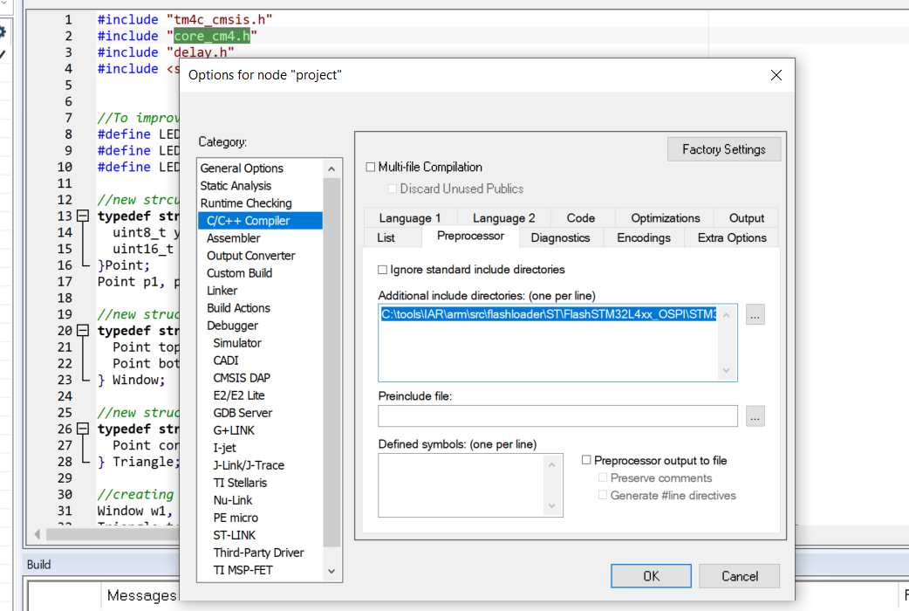
    - **Click OK**
  + Write this line above the code **#include "core_cm4.h"**
* This also tells the how you can add external files

**Lesson# 13: Startup Code Part-1: What is startup code and how the CPU gets from reset to main?**

* We will talk about the startup code, the code that runs even before the main function, this is standard startup code that links with your application from the IAR library
* You will learn how the startup code initializes various data sections, you will these sections in the linker map file, then you go back to reset sequence and encounter the vector table
* Till now we are starting our programming in main function today we will see the worl before main
* We do the following steps if we want to do it ! Options->
  + Debugger -> setup -> **uncheck Run to ->main**
  + Debugger -> Download -> **Check Verify Download, Use Flashloader-> Override Default board file**
  + General Options -> Target -> Processor Variant -> **select Device**
  + General Options -> Floating Point Setting -> FPU -> **VFPv4 Single precision (as this device uses hardware floating point unit)**
* Now lets examine in debugger !
* The first things we noticed, all registers are initialized to 0, SP register has some value of RAM, **the code execution begins on iar_program_start**
* Lets examine the instructions:
  + The first important command we encountered is BL which is the function call as we already know that, which calls the function __iar_unit_vfp, which is the function to initialize the Floating point unit **FPU,** FPU must be initialized early if code needs to use it later like main.c
  + The 2nd important isntructio BL on **?main, which is illegal** way of naming the function, since we are in strange world **before the C language, so the C rules for naming function don’t apply.** Lets enter inside this function and analyze
    - The first instruction we encountered is the **__low_level_init** which is a function to initialize the customize initialization of the hardware which speeds up the process, for example, customized clock speed of hardware must be set early on, if you don’t define your __low_level_init which you are doing it now, an empty library version is used, __low_level_init returns a value which determines whether to go call straight and call to main or to perform data initialization, the library version return a NON-ZERO version so the __iar_data_init3 is called
    - **Keep running through the code and you end up calling the main function**
* We skipped through the code because it doesn’t have all the data sections, now we modify the code in a way that, all data sections must get appear
* But what is DATA SECTION? We will look at the sections in the program! To see that you need to enable the generation of **map file by the linker, how do we do that?**
  + **Options->linker->list->Tick Linker Map file**
  + Rebuild the code fn+f7
* You look at linker map file which is in output folder. It is very important to read and understand the information of the generated linker map file for any embedded systems programmer it is very crucial
* The first important information you should know **how big your program is, in terms of code spacing ROM & Data Space in ROM and RAM, to find this, scroll to the MODULE SUMMARY section,** lets examine this section
* You find ro code(read-only code), rd(read-only data), rw data(read-write data), delay.o, main.o sizes which are object files.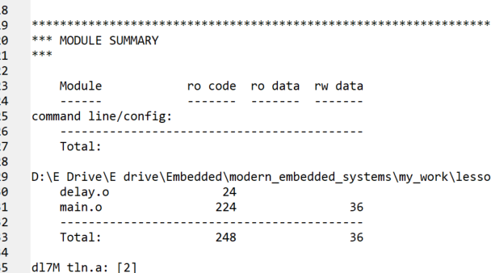
* below the table you find out the size of ro code, rd data and rw data, the data I get, 546 bytes of ro code, 18 bytes of ro data, and 1024 bytes of rw data which is pretty high 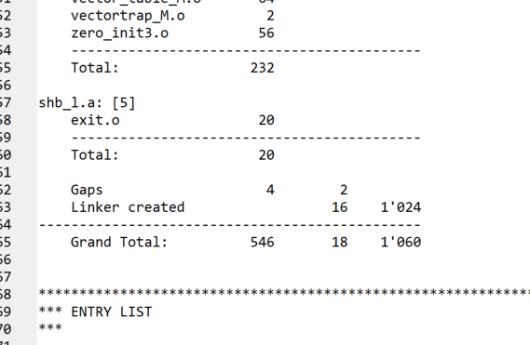
* The most important section of the linker file is **placement summary** which lists all the program sections
* Program sections are adjacently chunked memory sections, example
* Section P1:
  + Area between 0x00000000 and 0x00000040 are named .intvect
  + The following section**s** are .text sections which are **ro code**
  + Also .iar.init_table section is also there which is linker creation table which is constant
  + We also have .rodata
  + All these addresses are in ROM section of the memory
* Section P2 part 1of 2:
  + .bss section which holds uninitialized data, that need to set to 0 during system startup
* Section P2 part 2 of 2:
  + CSTACK section which holds the stack and remain **uninit** means remain uninitiazed during the startup
* All these names are all historical names coming from some **Aseembly Language, example : .bss=> block started by some symbol**
* The thing to focus on is that, your program doesn’t have any initialized data section yet, which is the data section that require specific initialization to hard coded values during the startup
* Now we will add some data initialization and again check our map file
* We declare and define some variable globally, even the arrays, lets discuss about the array initialization
  + When you define the size of the array [n], you can left it empty, the C compiler will omit the size from the initializer, you can leave n greater than tha num of elements, in this case the missing unintialized elements will be initialized to 0, but n cannot be less than the num of elements of an array
* In the same way initialize the hooks of earlier created struct, for each initialized hook you can make it as a simple variable or a list, also the **lists of list** , **built-on-top-of-hook**
* Now lets examine the code, the changes appeared after initialization in code:
  + Under P1 which is ROM space has new Initializer_bytes section is added
  + 2 new .data section has been created at the RAM address range
  + At the same time 2 .bss section have disappeared
  + The combined size of 2 new .data section are 0x0C bytes, which is equal to the Initializer bytes section of ROM

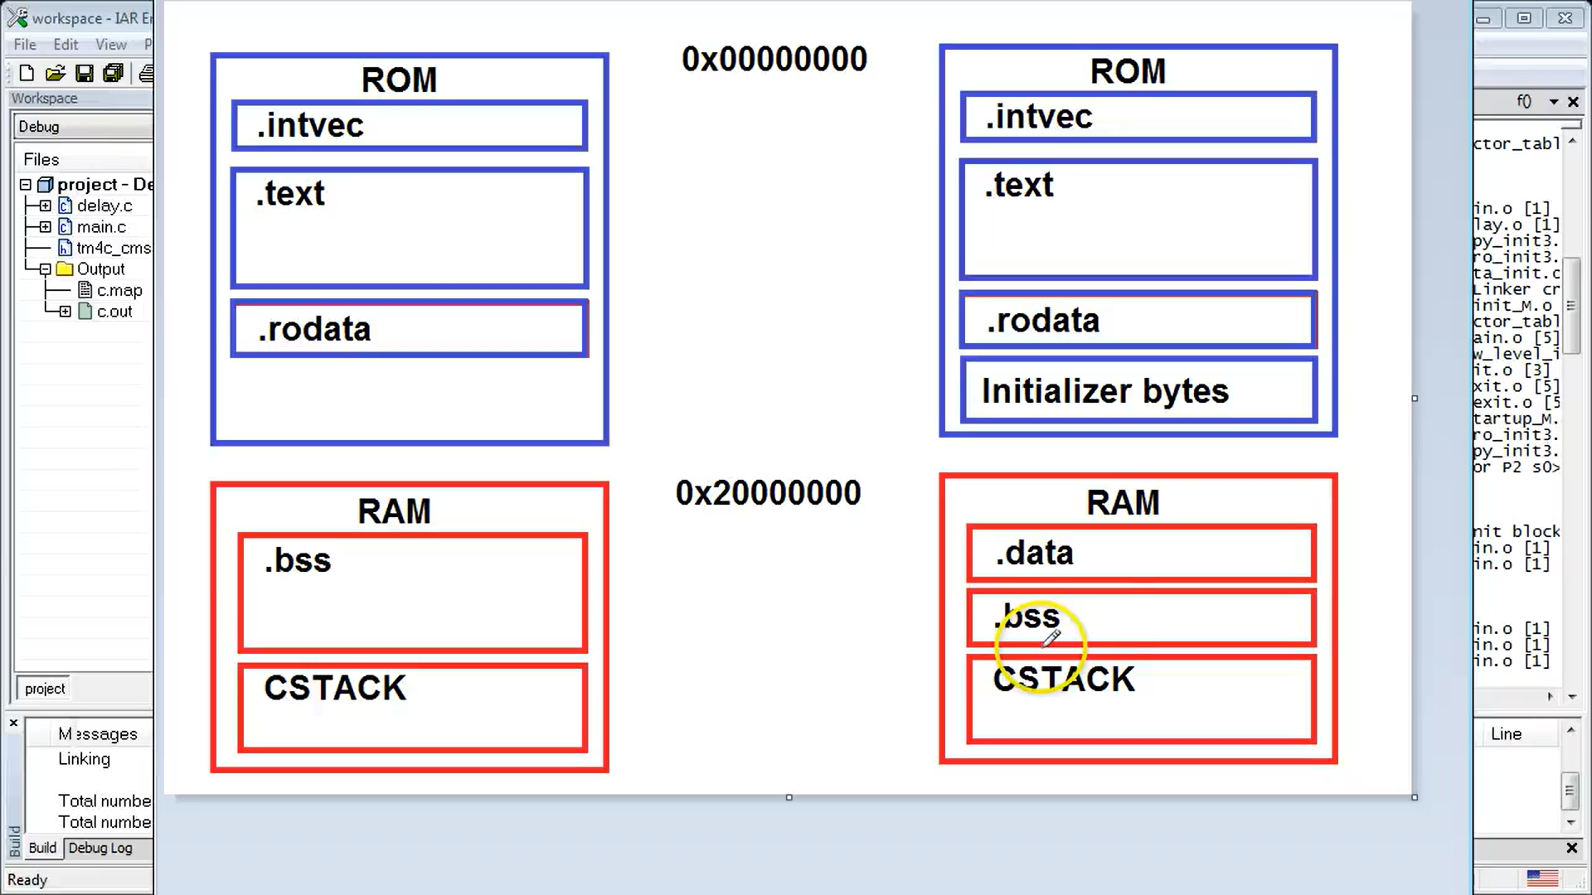

* When you initialized global variables, on the above image, the RHS initialized memory in ROM and RAM is being created.
* The affect of startup code is that it copied the initializer bytes section from ROM to .data of RAM memory
* Now you have both initialized and uninitialized data in .data set and uninitialized data in .bss section
* Fill the garbage vakues in from 0x20000000 -> 0x20000024
* Stepin through the code and analyze __iar_zero_init3 which is inside ?main fucntion
  + **LDR.W** initialized with 0
  + **STR.W** core of data clearing algorithm, instruction stores R3 into R2
    - **R2 has exact address as of first .bss section of RAM**
  + **#0X4** this cause the offset of base register by 4 bytes->suitable for tight loops
  + **[#0X4]** adds offset on the base temporarily before storing the data
  + Each step in clears the .bss section
  + We observed how it initialized to 0 or clearing .bss
  + After clearing .bss the startup code proceed to .data section
    - The actual copying is done by LDR/STR instruction that used the addressing that we have just discussed above in .bss section
    - R2 register of the LDR instruction points to the source of the data which is the beginning of the “initialzer byte” section in ROM
    - R3 base register of LDR instruction points to the target of the data, which is the beginning of the .data section in RAM
    - The code again initialize whole data section
    - Until eventually startup complete and the main function is called
* SUMMARY OF ABOVE PICTURE:
  + Startup code provided in the IAR library
  + By the time **main** is called to the C standards requires all initialized variables to have their initial values and all uinitialized variables set to 0, however startup code from other vendors not comply with the C standards
  + Sometimes you encounter with startup codes that does clear your uninitialized variables in the **.bss** section
  + EXAMPLE: The startup code of Texas Instruments DSPs routinely does not comply in this respect
  + MUDDA IS : YOU SHOULD TEST YOUR STARTUP THE WAY YOU HAVE LEARNED
  + **If you find out that your .bss section is not cleared, you might need to explicitly initialized the all previously uninitialized variables to 0**
  + This is not optimal to set to all 0 as your specially convert the .bss to .data section which required **matching initializer bytes** section in ROM
  + **In other words you take space in ROM FOR A BUNCH OF ZEROS**
* Now we begin answer one important question which is:
  + How the SP get its initial value
  + How PC end up at the project.map instruction’s **__iar_program_start**
* The clues of this answer can be found at address 0, which is the start of ROM 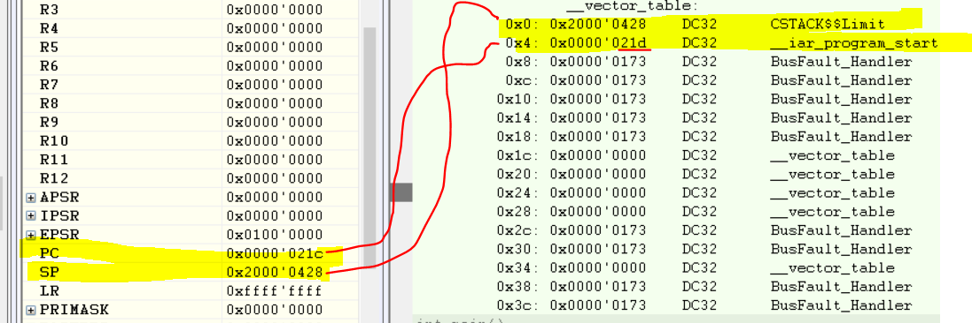
* CSTACK$$Limit at address 0, __iar_program_start at address 0X04
* Answer to above questions: The ARM CORTEX-M processor is hardwired such that after reset, it copies the bits from address 0 to the SP register, and all the bits except LSB from address 0x04 to the PC, because the LSB of any value loaded to the PC must be 1, because this mode indicate the THUMB MODE which is the only mode supported by CORTEX-M, this also explains the why the value at 0x4 is 021d (02113)-ODD and at PC it is 021C(02112) -EVEN
* The address 0, the so-called vector table, the vector table is describe in the datasheet at 2.5.4 which you can read what you already know, that it contains the reset value of stack pointer and the start address of the PC, but the vector table contains more than that, it contains all the exceptions amd interrupt vectors that your processor can handle
* Unique Thing: The vector table inside the datasheet is exact opposite upside down match of other table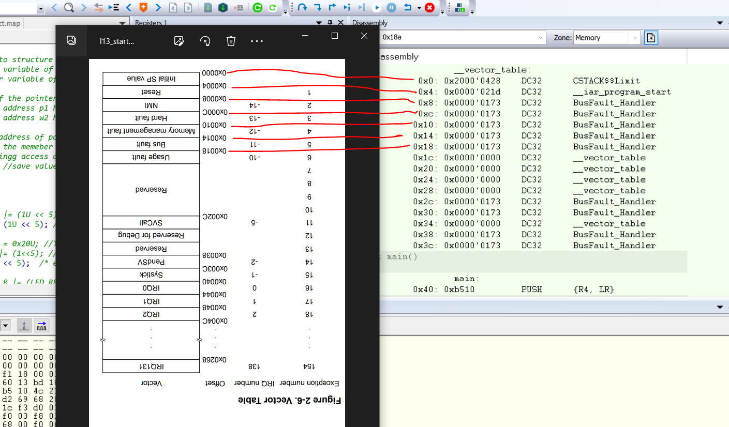
* Since the Vector table provided by IAR library is generic thus it cannot show all the comonenets of vector table as shown in the datasheet, generic means that it contains standard exception vectors that are defined at the beginning of the table and are common to all cortex M microcontrollers, IAR table doesn’t contain **interrupt vectors** that are specific to a given specific microcontroller such as **IRQ0, IRQ1, IRQ2**, that is why it cannot handle any interrupts, for that you need to replace generic IAR table with a specific one that will exactly match the layout which is defined in the datasheet of your specific microncontroller
* Lets examine the fault handler code
* The IAR startup code defines all exception handlers such as BUS FAULT, DEBUG MONTOR, HARD FAULT, MEMORY MANAGER AND NON-MASKABLE INTERRUPT, they all point to the same piece of Code knowing only this common address 0xe7fe, the disassembler could not distinguish among the various exception handler, amd chose only to show the bus fault handler because this is the first one in alphabetical ORDER
  + The IAR code that is associated with these exception handler turns out to be a single branch instruction B.N which jumps to itself, this means ocuurance of ant of the exceptions ends up tying the CPU in a tight endless loop, this is good for debugging, because when you break-in to such code, you will find looping inside an exception handler, but such a primitive policy is unacceptable for a production code because the device will appear completely lockes and unresponsive, this is known as the denial of service

**Lesson #14: Startup Code Part-2: Replacing the vector-table, embedded software build process**

|  |  |  |
| --- | --- | --- |
| **Time** | **Capture** | **Create** |
| **0.20** | Generate Generic Vector Table of our own |  |
| **1.27** | Last we saw that we don’t have interrupt vectors due to only have generic IAR code |  |
| **2:28** | Embedded Build Process | You working on cross development platform where your computer which is host run IAR software which has compiler and linker, even though the code is being developed for the different board which is your TIVA C board, native development is very opposite of, use mainly in dekstop development |
| **3.27** | Process of how your main.c become executable to the controller | Main.c and delay.c ->c-compiler->main.o and delay.o which are not executable because it doesn’t specify any memory location and library references, that’s where linker comes in and which takes in main.o, delay.o, libraries, project.icf -> project.out which is executable code which is also an elf file to controller |
| **4.38** | Format and location of .o file | Inside your CWD of project Debug->Obj-> main.o and delay.o.  The file formats are ELF (Executable/Extendable Linker Format), most popular format but not the only one format which use by modern compilers |
| **5.03** | Dumping the .o into human readable fromat | The file named “ielfumparm.exe” a command line program to dump the contents of .o / elf file into human readable format  Other application use by GNU Compiler is “objectdump.exe”, you can use it on .o file of IAR |
| **6.20** | Opening and understanding the .o file by the “ielfumparm.exe” application and understand the contents | Upon opening the contents, we encounter .bss .data which we have already encountered in startup file, and symbolic information for the linker and lot sections contain the debugging information of the debugger |
| **6.52** | How to determine the actual file size of all modules | It should be noted that .o file is a tool like other parts of the compiler, thus it should not be a correct source to learn the information of file size instead linker file **project.map** is a correct source to findwhich you encountered last lecture |
| **7.47** | Prepare for Comparison between main.o VS c.out | Convert the c,out into human readable by ielfdumparm utility and compare section#16 of main.o with section#05 of c.out |
| **9.19** | Comparison of BL instruction among the .o and .out file through elfdemp tool | Since we know that .o doesn’t have address of where the delay function is ! that is why it attaches the generic signed offset like 0x7ffffffe, this offset is fixed by the linker when linker decides where the delay function is by creating a correct address |
| **10.35** | Appreciation of linker | .o file also assign generic address to the declared variables because it also doesn’t know where the actual address of the variable is, this solves by the linker  Linker must be specific to the target processor, means linker of x86 which is your controller on PC, that linker cannot be used with the .object file created by the compiler of ARM even through both are same code and same elf file  **LINKER IS LOCATOR**  **LINKER IS GOOGLE MAPS** |
| **10.35** | How to dump and create a .txt file with windows cmd | Add the directory where ielfdumparm tool is available and paste the directory into system variables  Then go to the directory where the .object file is present then write this command **ielfdumparm.exe --all main.o > main.txt** |

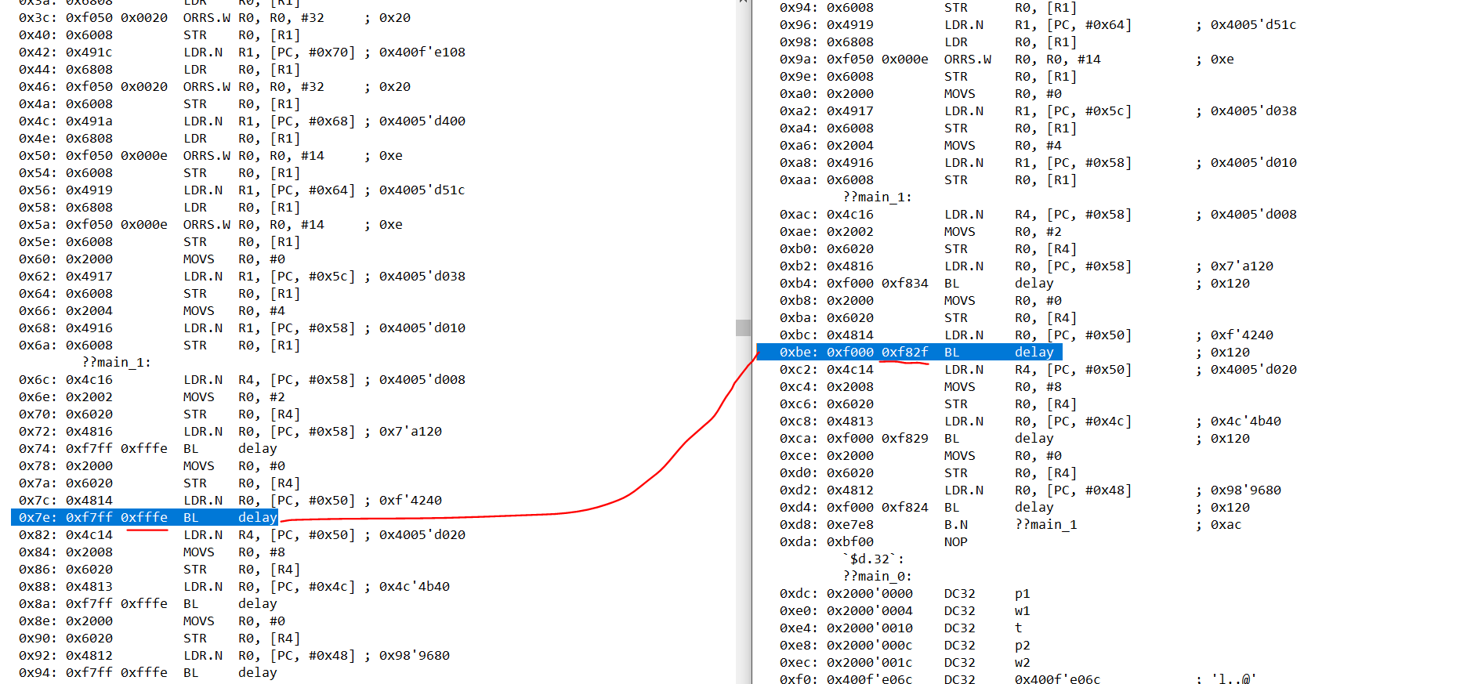

|  |  |  |
| --- | --- | --- |
| **Sno** | **Capture** | **Create** |
| **13.47** | How the linker resolves cross module references between variables and function and functions of libraries | When executing begins, exported list is empty and undefined list contain __vector_table  Linker matches **export symbols** and **import symbols** of any object file with the final image it carries, its final image has 2 lists, after linker processes all main.o file, it adds the exported symbols of main.o to its final image which is **Exported List,** this exported list also take import symbols of main.o and try find its export symbol of main.o, if it finds it, it adds to the exported list, if not then adds to the undefined list, when linker processes delay.o it does the same, delay.o export symbol contain delay symbol which when taken by exported then and there undefined list removes if any exported symbol have any undefined element in this case, it removes the delay.  Since the final image does contain the __vector_table, it will again searches for it, __vector_table symbol is present at the **vector_table_M.o inside of IAR library rt7M_tl.a** which is an object file as well, it  Linking rule is different when linker is dealing with libraries, because the library search only begin if __vector_table is present in undefined list |

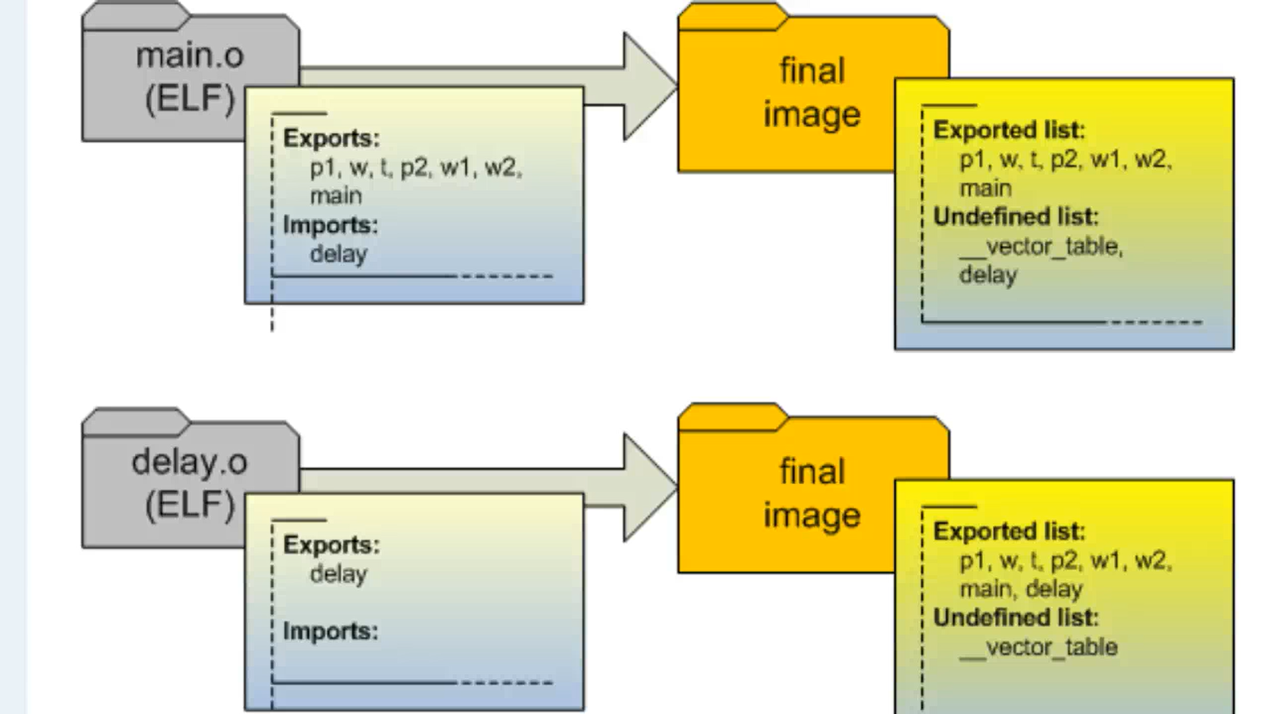

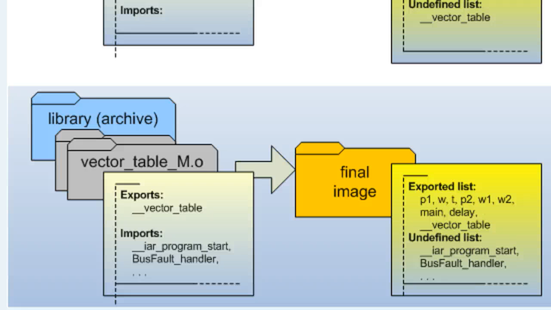

|  |  |  |
| --- | --- | --- |
| **SNO** | **Capture** | **Create** |
| **14.41** | Verify that __vector_table is present inside vector_table_M.o | I search Throup **project.map** file the **__vector_table** |

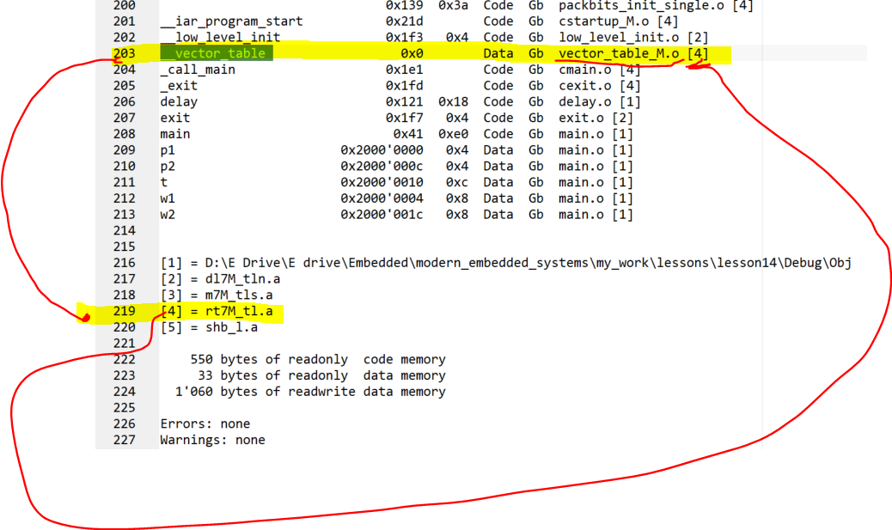

|  |  |  |
| --- | --- | --- |
| **SNO** | **Capture** | **Create** |
| **16.30** | How more libraries are linked, Why small object are necessary in your libraries | As we look at the previous 2nd last image above, its imported symbol contain __iar_program_start which found on same project.map file, that __iar_program_start like other symbols is being imported from another object file named cstartup_M.o, AT THIS POINT the linker applied another rule, which is if any symbol found to be in the undefined list of the final image then it continuously searches through the object file until it gets empty, interestingly project.map imports the main symbol but it is being defined in the file, thus it includes in the exported list of the final image  The basic layout that we can smell is that the object files contain 1 or 2 symbols because, at every stage the final image at **every stage** only takes the stuff that actually needed at that stage, if .object contain multiple variables and symbols, so you would bloat the final image unnecessarily, so when you are making your own libraries, always make symbols **small,** by average you only define 1 global variable and 1 function per module/object |
| **17.47** | How to resolve the linking order between the libraries | This only needs to do when the undefined list of the final image still contains the symbol and linker could not find out where the f is its object is, then you need to resolve this issue by reordering libraries and ocassianlly specify some libraries more than once in **the linking order to resolve the circular dependencies among them** |
| **18.43** | How a vector table is being created | Here you have set the order of the libraries to link because you want to link your newly created library to be first linked  Since our goal is the make our own __vector_table because generic vector table doesn’t have interrupts, so we created this as the .c file into the project create __vector_table as the export symbol to satisfy the final image |
| **20.20** | How a C module can accomplish anything at the startup time even before the machine is not ready, by means machine is not ready for executing C ->> SP is not setup yet, the initialized data haven’t copies from ROM to RAM as in lesson #12, and the .bss section is not cleared yet either | Yes you are right, infact An startup code for most other processors cant be written in C and requires you to use Assembly Language, however the **ARM CORTEX M** specially design to reduce the need for to do low level assembly programming, even for cortex M, the startup still requires some non standard language extensions and of course you have to be careful not to assume any initialization of the .data section or clearing of .bss section, code in the file, set __vector_table as exported symbol which here is an array |
| **21.25** | Placement of vector table in correct memory(1) | We need to see where linker put the original table form the library, open project.map file and see default __vector_table is in the **.intvect** section of the memory that has the address of 0x00000000 at ROM  Still we don’t understand how this section is being defined! Thus we need to open **linker script file project.icf** file, you also know here that the linker script purpose is to tell the linker where to place the various merged program sections in the address space  Open project.icf from IAR workbench |
| **21.27** | Placement of vector table in correct memory(2) | After opening the file the script is generated by the **linker configuration file editor**  Access this edtor file by **options->Linker->config->Linker Configuartion File**  **In the dialog box, select the project,icf and click edit** |
| **22.17** | Placement of vector table in correct memory(3)  How to control the linker configuration file | -The location of .intvect controlled by **Vector Table’s** tab  **-Memory regions** controls the starting and ending addresses of RAM and ROM  -Controls the size of CSTACK and HEAP |
| **23.29** | Placement of vector table in correct memory(4)  How to place your vector table in special ,intvec section of project,icf file | In project.icf the .intvect section defined in the **place command** at the bottom of the linker script, the section is readonly and is placed at the address specified by the variable **ICFEDIT_intvec_start**  All this are important to your own startup because you need to makesure that your own vector table is placed in this special **.intvec section**  Leider, there is no standard C syntax available to place your vector table in specific sections, but IAR provides an extension  After [] in array of vector symbol of your created ibrary add **@ ”.intvec”** |
| **25.00** | Placement of vector table in correct memory(5)  How to forcefully place your vector table in the ROM specific address | The changes above appear as that your newly created .intvect section at random RAM address but it should be at 0x00000000 as the generic table was, the problem is your vector table is a variable that can change the compiler cannot put **.intvect into readonly memory.**  For that you need to add **const** keyword which behaves as same as volatile keyword  Replace the elements of vector table from 0 because it will hung the board to 0x20004000 and 0x0 |

* **When I didn’t replace my generic table: .intvec is importing from vector_table_M.o**

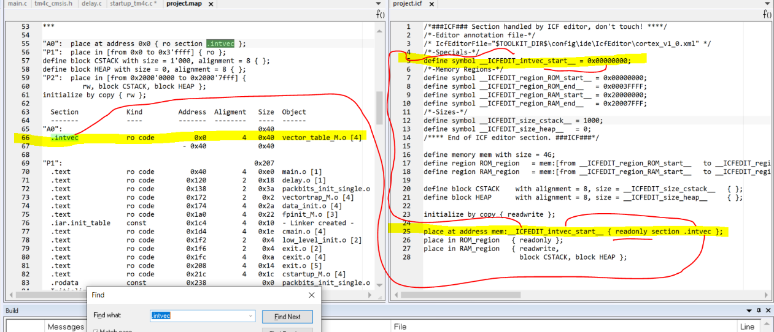

* **After I place my own created Vector Table to satisfy the final image: intvec is importing from my own created startup_tm4c.o. YAYYYYYYY**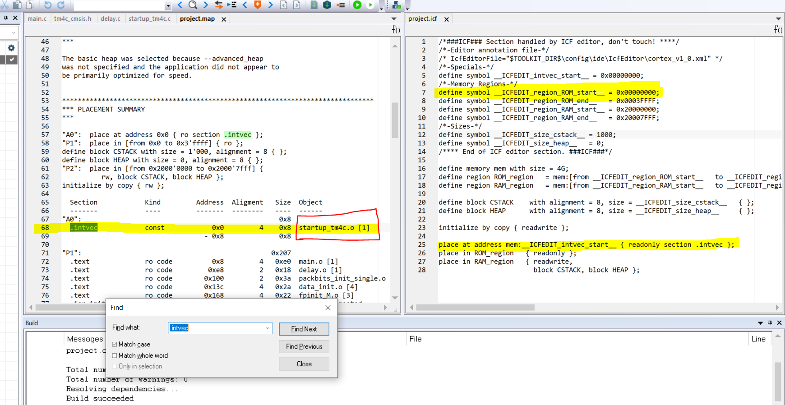

**Lesson# 15: Startup Code Part-3: Vector table initialization, exception handlers, interrupt handlers**

|  |  |  |
| --- | --- | --- |
| **SNO** | **Capture** | **Create** |
| **2:18** | To create a vector table with correct initializations for SP and **Interrupts** | We use vector table as the reference from the datasheet of controller |
| **3.12** | How to initialize SP | We take reference from previous code of lesson #13 workspace, where it is using the default library and which connects to old generic default table and look at address 0x0 IN DISASSEMBLY and the first entry on the vector table is **CSTACK$LIMIT**  this indicates that, this entry is already known to the linker  How its known to the linker? Next section |
| **7.57** | How to initialize SP in Vector table just like generic file does | After looking at datasheet we understood that the SP is present as 0x0 on vector table of the required controller as **initial SP value**  Then we understood how Linker generates **symbols**() in case any section is defined in the program, these symbols places at the specified memory locations ,which you can find using  Help->Content->Search->C language extension  Symbols are  -**sec$$Base - places at the beginning of stack which is Upside of RAM**  **-sec$$Limit –places at Lowside of RAM and it initialize the address of stack which grows to sec$$Base**  **-sec$$Length**  Now when we placed the **&CSTACK$$Limit** which is the address of the symbol inside the vector table, but error thrown by compiler because, the linker symbols generated after the compilation, thus we need to export the symbol to the compiler before using it.  Also we need to makesure that instead of creating variable definition which cosumed some space in the memory we want our exported symbol without allocating the storage to it, this can be achieved through the **extern keyword**  Apply exclusive type cast int on the &CSTACK$$Limit, because pointer to int cant be initialized entity of type int which is the **type of vector table**  **Now we verify whether your initialization worked correctly or not** |

* **The explanation of sec$$Base and sec$$Limit** on stack

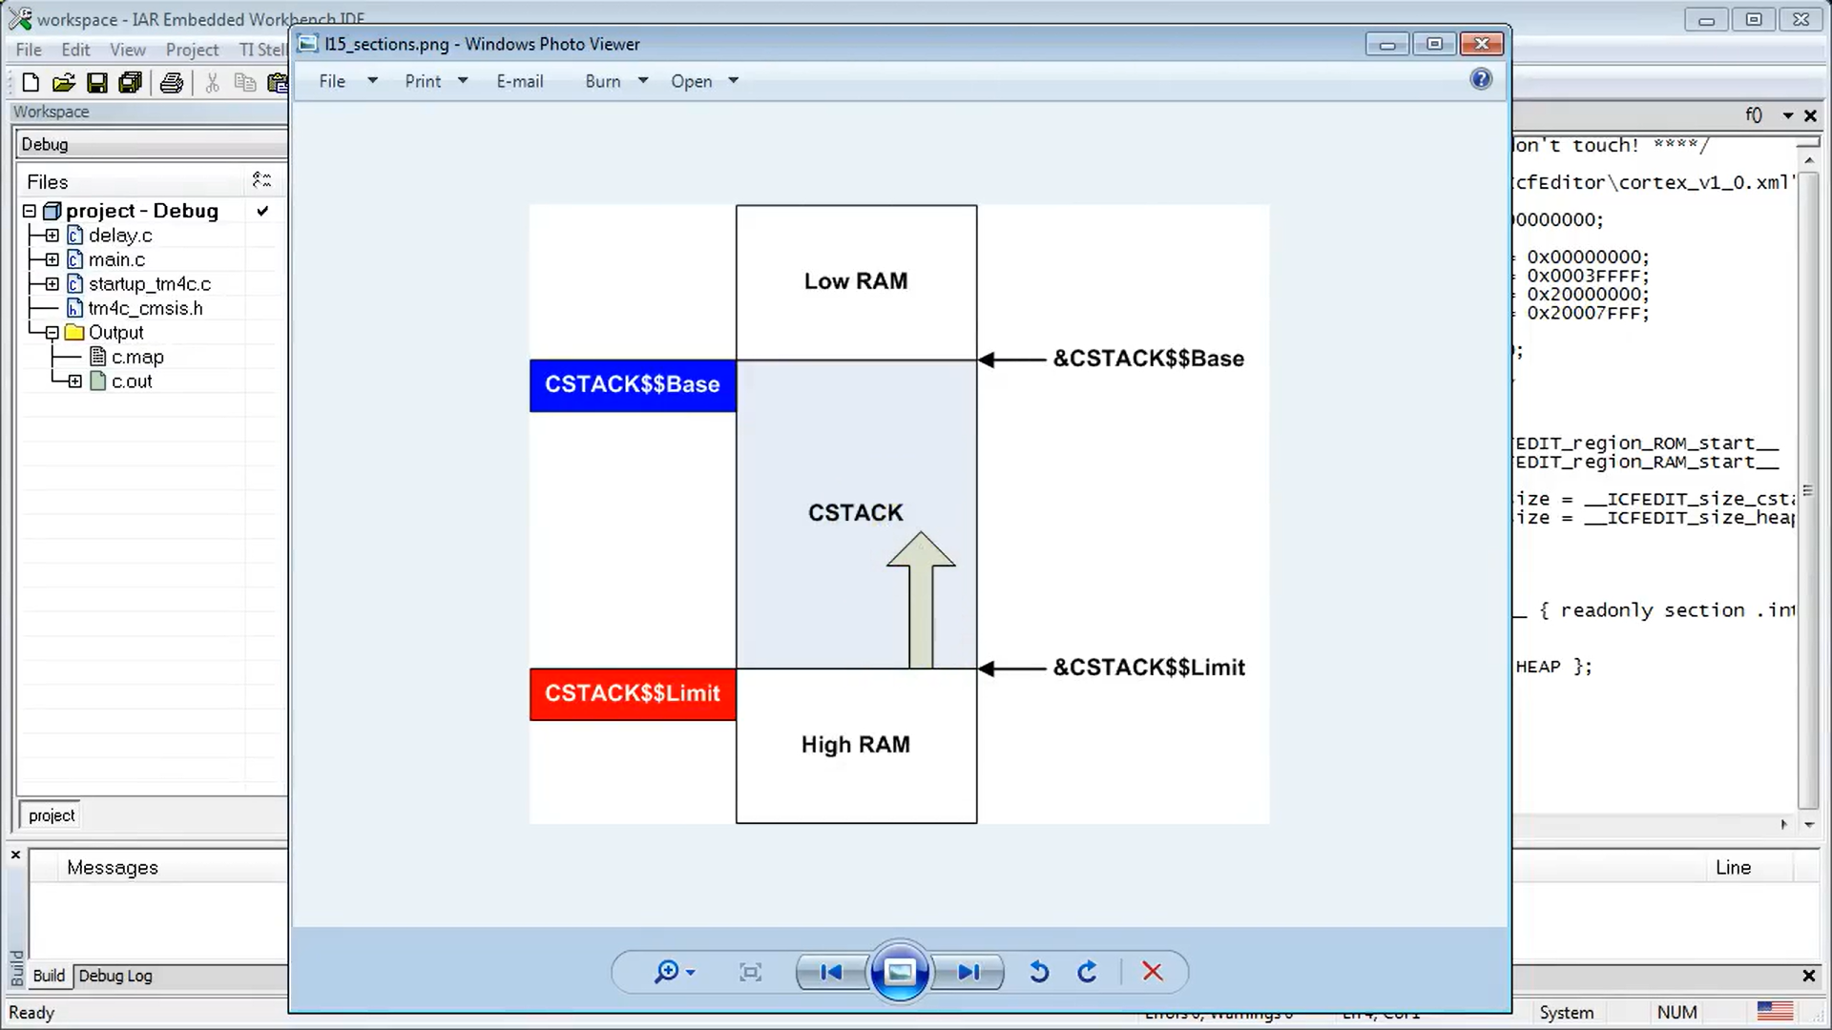

* **Location of SP on vector table:**

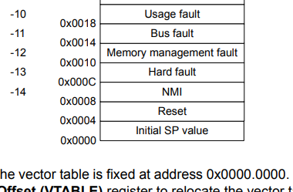

* **Address** of SP I initialize it:
  + Before Initialization: The SP pointer has CSTACK$$Limit with address of 0x20000408 but DISASSEMBLY Window showing 0x200000410
  + After Initialization: The SP pointer has CSTACK$$Limit with address of 0x20000410 and DISASSEMBLY Window showing 0x200000410

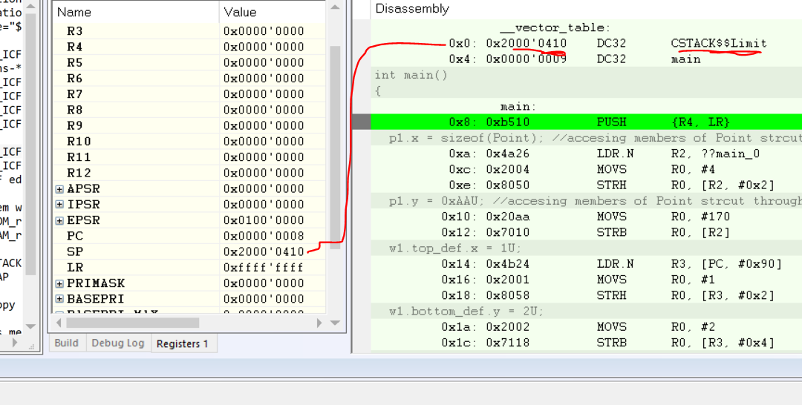

* You can also verify that by opening project.map file’s ENTRY section that Linker is created with the address

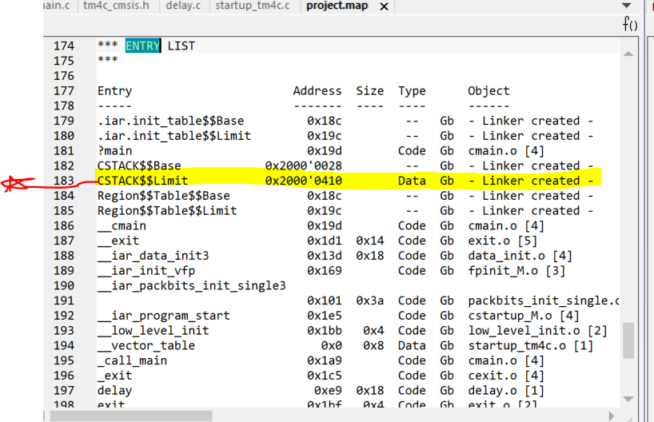

* How to verify that the SP is initialized correctly is by changing the **CSTACK to 1024 of project.icf file** and check whether the size of the CSTACK$$Limit in project.map increased or not?

YES THE VALUE INCREASED, HENCE VERIFIED THAT THE STACK POINTER IS CREATED

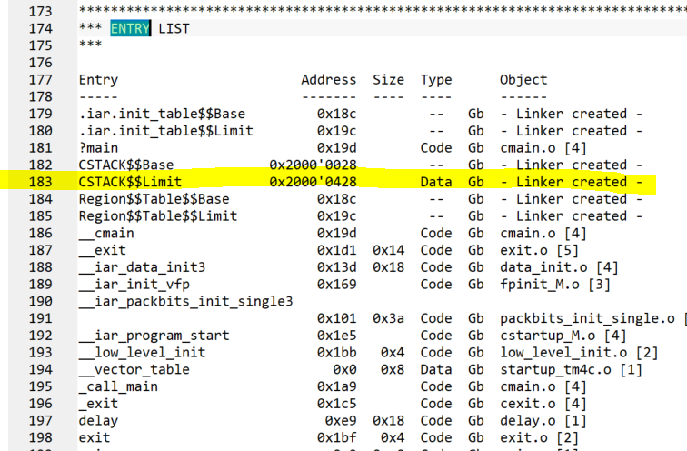

|  |  |  |
| --- | --- | --- |
| **Sno** | **Capture** | **Create** |
| **12.28** | How to create other exception handlers and interrupts as defined in the datasheet of controller ?  We look at how Reset Exception handler to be reset | -On datasheet Look at the table: suggests that it is located after the Initial SP at address 0x0004  -What is reset handler? Initial Value copied to the PC register when the microcontroller comes out of **reset phase,** its address also suggests that it sits in ROM, where the controller begins executing the code  -Look at default initialization of **Reset Handler just like we find it for SP,** which we found in previously generated workspace file which uses **generic vector table**  and find which symbols that location is uses  -It is found out that the reset handler is set to __iar_program_start workshop disassbly in lesson#13  -How to access the address of the function? Just like the address of a variable, also declare it with void type and set its returing type to be coid since it is a function unlike you did to variable, also use (int) casting inside vector table  -The address of a function can be obtain even if you don’t use & sign before it, but coders usually use it, so we also  -How can you verify it? Just check values of PC value, and matches under the **__iar_program_start which is a** symbol of reset handler |

* How to verify the Reset initializer created
  + First run the code, if it runs correctly then your reset is correctly initialized
  + Second verify that __iar_program_start have the same address as the address of **PC** 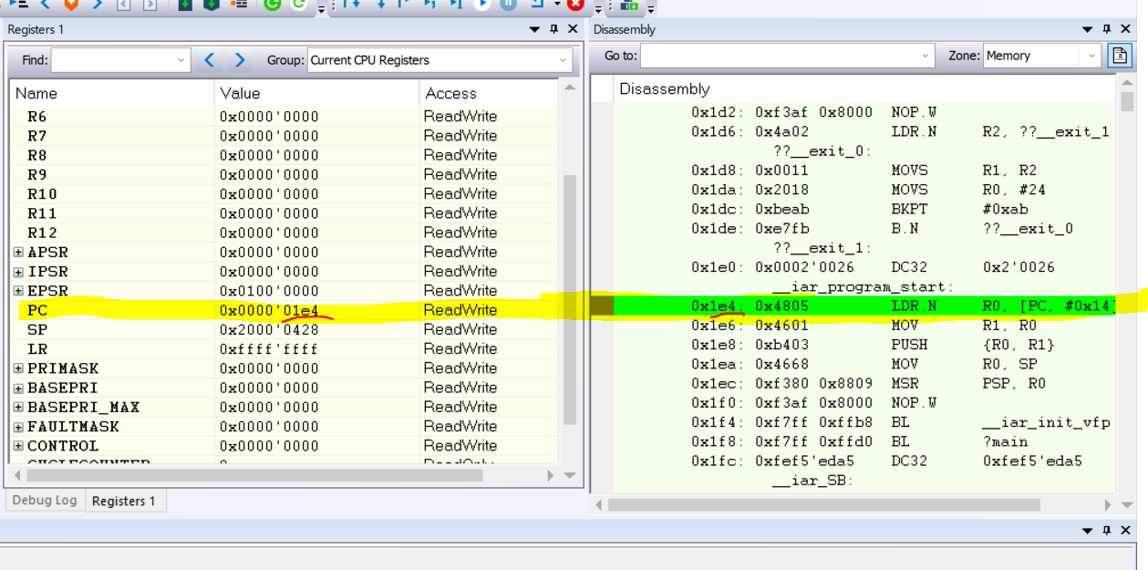

|  |  |  |
| --- | --- | --- |
| **Sno** | **Capture** | **Create** |
| **14.24** | To program the exception handlers | Checking the all the exception handlers and their location just like we did previously with the **Reset Handler,** One good example and visualization of handler of HardFault_Handler which is now part of the Fault handlers you are currently dealing and also it was occurred in **lesson#10,** where it was occurred because the SP registers drops below the RAM and **stack overflow** appeared  You can read more about these excpeption handlers later in datasheet under heading **2.6 Fault Handling**  One important observation need to be carried out is that the all fault handlers are not adjacent but contain some reserved bytes, the order and occurrence at which they we need to replicate it in the **vector table** that we are creating  We found all the functions just like **Reset Handler,** here also note that, all the reserved slot are represented in the vector table as **0,** you don’t need to declare the prototypes just like you did in **Reset Handler,** instead it is present in **tm4c_cmsis.h file,** you just import that file here  Always remember to use only the standard names of the function just like mentioned in the standard tm4c_cmsis.h standard because this will be useful when you gonna deal with 3rd party softwares or RTOS |
| **16.14** | How to design your own exception handler->Fault Handlers | Define a function which you inserted inside the vector table here, that function’s prototype is already inside tm4c_cmsis.h file.  If you just leave the while loop inside your defined function the project will into the “denial of service” which appear when on devices when you are dealing with the devices whose battery need to be removed to restart it, in such cases the fault handlers are not correctly design and leave such while() loops.  Instead we should use call function, inside the definitions of fault handler which defined on vector table, I use **assert_failed() call** which is already declare inside the tm4c_cmsis.h thus it is being used here, this function controls the damage(NORMALLY RESETTING), by reporting the line number where the error is appeared by its 2nd paramter which is __LINE__ a macro to report file number, 1st parameter specify **the fault handler name,** if you look at the paramters of the assert_failed() prototype, its first argument basically an error file which dependent on the passing in argument which specify the fault handler name  We have DEFINED functions for 5 fault handlers named “HardFault”, “NMI”, “BusFault”, “usageFault” and “MemManage” which are typically call here the same function **assert_failed()** |
| **18.30** | How to design your non-fault handlers | The exception handlers are of 2 types, fault handlers which discussed above-adjacent point and the others are non- fault handlers which are “SVC_Handler”, “DebugMon_Handler”,”SysTick_Handler”  Instead of treating them as faults, we have to provide a pipeline to them, the pipeline leads to **unused_Handler** which historically loads into the final image, so the executing enters into the pipeline and take all these exception handlers to become **unused_Handler** only if the definition of the specific exception handler is not present, this method of handling the exceptions are called **weak alias for a function,** which implemented in the startup_tm4c.c FILE, where this unused to be exported to image, it is defined in the same file and also declare/prototype it as well  But when I ran the project it throws an error that **assert_failed() is not defined**!!! Because although you have **already imported the protype from tm4c_cmsis.h**  but **where it is being defined?** That is why you need to define it in your project, create a file named **bsp.c** which Board Specific Package, as this is only specific to your board |
| **19.15** | How to design the calling functions by the **exception handler functions** | 1. Put only board specific stuff as the this file is specific to your board adds **tm4c_cmsis.h** file 2. Put here Board specific stuff such as **error and assertion handling policy which is basically the assert_failed definition, also put here specific interrupt handlers** 3. **How To design your assert_failed function?**   **1st thing:** define a function how you handle **Damage Control Function->**depend on project and handles the error recovery strategy  **2nd thing:** reset the system by **calling** the function **NVIC_SystemReset()** from tm4c_cmsis |
| **21.00** | Result of testing | Debug the code, you will find out the exact order of handlers are appeared which is what we wanted, one more thing we see strange is that, **all** non_defaullt handler are appearing as **DebugMon_Handler** because all non-deafault handlers referred by the single alias which means the single address  To test this hypothesis we define new function **SysTick_Handler** handling the SysTick_Hanlder call, thus eventually replacing **unsued_Hanlder** which sew with the weak alias into **startup_tm4c.c** file  The results can be shown below |

* **21.00:Result**
  + **Exception handlers**

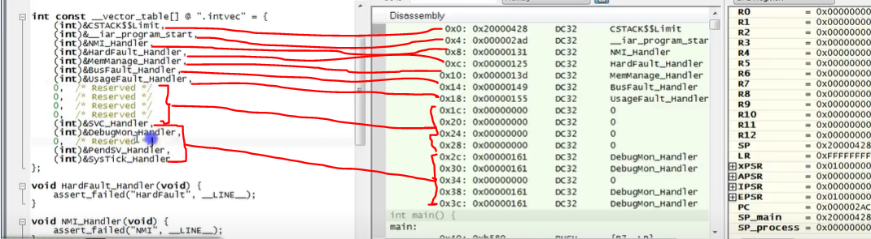

* + **Exception handler with SysTick defined**

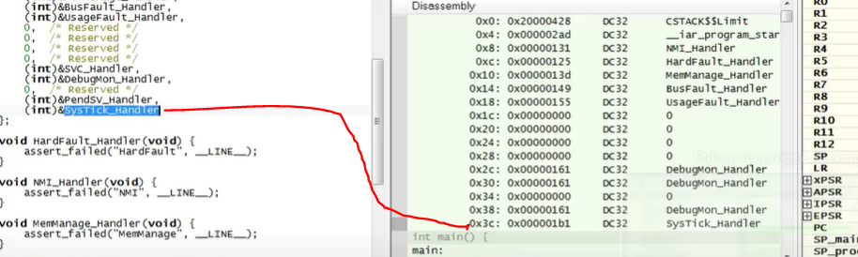

|  |  |  |
| --- | --- | --- |
| **Sno** | **Capture** | **Create** |
| **25.10** | Testing the handlers | 1. Run the code in debug and stops it while running 2. Set the breakpoint at the beginning of delay function 3. After the breakpoint is hit, change the SP register value to 00000000 4. Single step through Aseembly and then you get stuck at Hardfault_Handler because the **PUSH** instruction which **re-enters** thehardfault and eventually not calling **assert_failed()** function, your code go into enless loop and denial of service whice your goal here to avoid 5. **HOW TO FIX THIS ISSUE?** Don’t access the stack in your fault handlers exception. How to fo that? referred to IAR help file, use __stackless keyword before the exception handlers definition in startup_tm4c.c file , but there is warning as well that if you used it, it is impossible to return from it 6. **Now tested again assert_failed() function** being called |
| **25.45** | **Advice** | Develpe a habit of testing your part of code which will run rarely, use faul-injection method to enter errors manually to test how device behaves, like above we did  One disadvantage is that single breakpoint catch all the errors, fault, and assertions during debugging  We will learn in future how to hardcode the breakpoints in CORTEX-M |
| **27.35** | How to initialize the interrupt handlers IRQ0, IRQ1, IRQ2 | At table 2-9 you will find list of interrupts on data sheet  Do as just above, all the prototypes are already provided in the header file  Make all the interrupt handlers sew into **weak aliasing** |

**HOW YOU DEBUG THE FAULTS?**

**RUN THE CODE IN DEBUGGER AND STOPS IT**

**YOU WILL FIND DELAY() place the breakpoint and change the SP calue to 0000000 and single step the code and see if your assert_failed() function being called or not** 